.
Abstract— This electronic document is a “live” template. The various components of your paper [title, text, heads, etc.] are already defined on the style sheet, as illustrated by the portions given in this document.
Improve CAVs Safety by Appropriate Vehicle Longitudinal Speed Planning with the Preview of Path Friction and Curvature*
Liming Gao, Craig Beal, Kshitij Jerath, Sean Brennan. IEEE Member

INTRODUCTION
The traffic accident is fatal and has a huge negative influence on economic costs. [follow some data from reference] Many factors attribute to safety, but A large part of the accidents are caused by slick roads (snow, ice, raining, and so on) and overspeeding.
The accident modern advanced vehicle is already kind of smart, but can not avoid the ddd.
reasonwhichmakes cars become safer is the development
of theADASs (Advanced Driver Assistance Systems) such as EBS, LKA, and ESC, etc
And to avoid the accidents, many controllers have been developed for path tracking and stabilization.
Research into the performance of connected and autonomous vehicles (CAVs) and intelligent traffic systems has been increasing in recent years due to the possibilities of improved performance, efficiency, and safety afforded by the sharing of information between vehicles and each other and/or infrastructure, and the control of vehicles from this information.
But most of them are following to the path without considering the intensively road friction condition change (snow, ice, raining, and etc.). Take control when the states are out of stable and the controller has a Stable region.
Veering lane
For example, the driver may take emergency brake when enter into a split friction road.
Envelop controller, leave the path stably, Even they can measure the road friction in real time. And they reaction to the emergency when emergency happens ().
However, it is costly to equip each vehicle a smart system. Besides to smart, Another way is to provide preview.
We all know that it is safe if driving slowly. But how slow and when need to slow down is important. If we can preview then slow down appropriately, then not need complicated algorithm .

The Early estimation of friction and peak tire force, before the limits are reached, allows a chassis control system to work more reliably and proactively. Instead of simply reactive. [1]
With the V2x (V2V, V2infrastructure) cyber technology development, the road friction prediction is possible. The road friction measurement

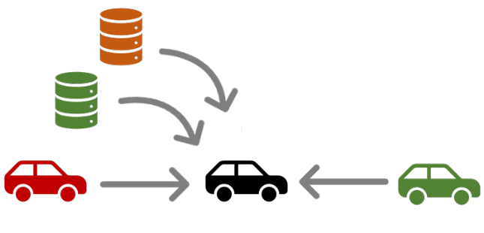
Figure 1. A strategy of road friction preview with a roadside shared roadway database. (need a better diagram to show the data sharing idea)

But the database update need time. How far inf we need ned to be answered. Less research has been done. We want to present the problem and give a pre-model.
In this paper, we introduce a framework for friction preview, and study the longitudinal velocity, which is critical for stabilization and path following control. And how long the preview should be .

The use of the proposed framework in this paper is demonstrated through a CAVs application example showing how the mapping of road friction enables advanced vehicle control by allowing the database-mediated preview of road friction. The remainder of this paper is organized as follows: Section II discusses the architecture of the proposed micro-simulation framework. Section III shows the application example. Finally, a conclusion section summarizes the main results of the work.

Vehicle Longitudinal Velocity Planning Given a Reference Path
This section presents the generation of minimum-time speed profile which vehicle can achieve without exceeding available road friction/vehicle handing limits [2]. At first, the approach to describe the path by s and κ is introduced and then followed by a detailed velocity planning method.

A. Introduction of GG diagram (maybe)
The shape of g-g diagram or friction circle depends on the road friction.

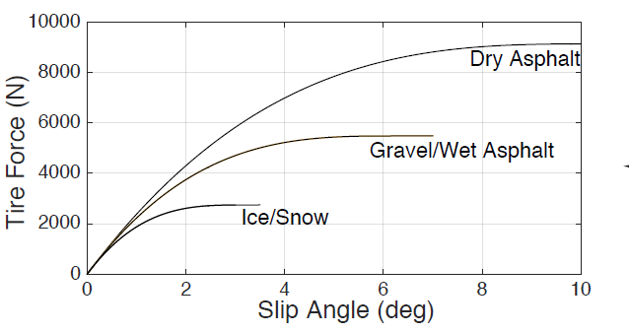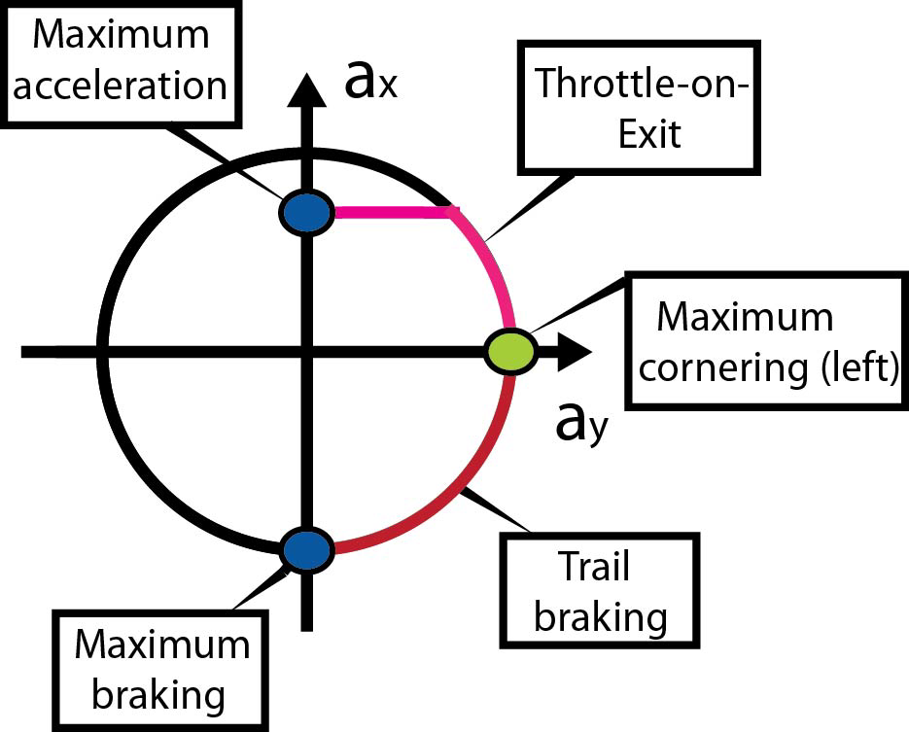
Figure 2. A plot of 0.9g and 0.2g friction circle()

A. Path Representation
The use of clothoids for general vehicle planning is not uncommon.[3] Minimum curvature[4] and optimal time.
Presents a sample path of S or ∞ like curve.
In real world, the grade of path also has significant influence on the acceleration and deceleration behavior.
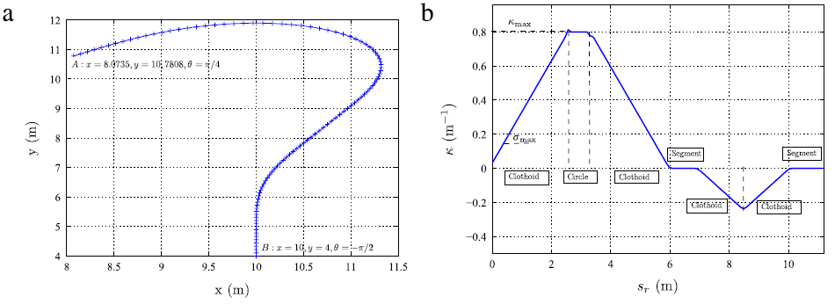
- A smaple path with friction varitation and may be grade

B. Velocity Profile Generation
Velocity planning has a significant impact on driving safety, especially when vehicles drive on a road with changing friction and geometry. In this paper, velocity generation is performed by considering the velocity and acceleration constraints. Three pass [2] , optimization [5], segment and iteration [6] .
However, they only consider the variation of curvature, and less attention has been paid to the friction.
The first step to generate the speed profile is to find the maximum permissible steady state vehicle velocity with zero longitudinal acceleration. If ignore the load transfer and road grade, this is given by (1):
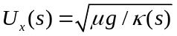

The friction circle can be represented by a simple relationship between 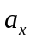 and 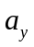 as follows:

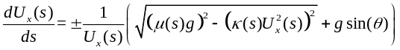

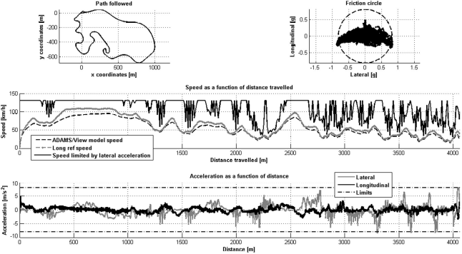
- A a sample of velocity profile

- A smaple path with friction varitation and may be grade

Preview Distance
In this section, we discuss how much friction data the vehicle needs to query from database.
Strategy can be: plan a velocity profile from start to the target, but it can not update with the newest data.

A. Minimum Preview Distance given Vehicle Current States
The worst case is entering a circle, with a sudden friction decrease.
The minimum curvature can be obtained from the path, and the minimum friction can be assumed to be 0.1 for conservation.
The distance is function of Ux, ax, max(κ), min (μ)
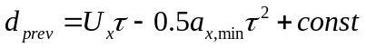

B. Identify the Headings
Headings, or heads, are organizational devices that guide the reader through your paper. There are two types: component heads and text heads.
Component heads identify the different components of your paper and are not topically subordinate to each other. Examples include Acknowledgments and References and, for these, the correct style to use is “Heading 5”. Use “figure caption” for your Figure captions, and “table head” for your table title. Run-in heads, such as “Abstract”, will require you to apply a style (in this case, italic) in addition to the style provided by the drop down menu to differentiate the head from the text.
Text heads organize the topics on a relational, hierarchical basis. For example, the paper title is the primary text head because all subsequent material relates and elaborates on this one topic. If there are two or more sub-topics, the next level head (uppercase Roman numerals) should be used and, conversely, if there are not at least two sub-topics, then no subheads should be introduced. Styles named “Heading 1”, “Heading 2”, “Heading 3”, and “Heading 4” are prescribed.

C. Figures and Tables

Positioning Figures and Tables: Place figures and tables at the top and bottom of columns. Avoid placing them in the middle of columns. Large figures and tables may span across both columns. Figure captions should be below the figures; table heads should appear above the tables. Insert figures and tables after they are cited in the text. Use the abbreviation “Fig. 1”, even at the beginning of a sentence.

Experiment
A vehicle with rear driving vehicle, and
A path with like 2 km, with the preview of friction.
A slow driver or medium driver, can follow the path well, even without advanced controller.

Conclusion
A conclusion section is not required. Although a conclusion may review the main points of the paper, do not replicate the abstract as the conclusion. A conclusion might elaborate on the importance of the work or suggest applications and extensions.
Acknowledgment
This material is based upon work supported by the National Science Foundation under grant no. CNS-1932509 “CPS: Medium: Collaborative Research: Automated Discovery of Data Validity for Safety-Critical Feedback Control in a Population of Connected Vehicles”. And CNS-XXX, Dr. Beal and Dr. Jerath

References
- G. O. Young, “Synthetic structure of industrial plastics (Book style with paper title and editor),” in Plastics, 2nd ed. vol. 3, J. Peters, Ed. New York: McGraw-Hill, 1964, pp. 15–64.
- W.-K. Chen, Linear Networks and Systems (Book style). Belmont, CA: Wadsworth, 1993, pp. 123–135.
- H. Poor, An Introduction to Signal Detection and Estimation. New York: Springer-Verlag, 1985, ch. 4.
- B. Smith, “An approach to graphs of linear forms (Unpublished work style),” unpublished.
- E. H. Miller, “A note on reflector arrays (Periodical style—Accepted for publication),” IEEE Trans. Antennas Propagat., to be published.
- J. Wang, “Fundamentals of erbium-doped fiber amplifiers arrays (Periodical style—Submitted for publication),” IEEE J. Quantum Electron., submitted for publication.
- C. J. Kaufman, Rocky Mountain Research Lab., Boulder, CO, private communication, May 1995.
- Y. Yorozu, M. Hirano, K. Oka, and Y. Tagawa, “Electron spectroscopy studies on magneto-optical media and plastic substrate interfaces(Translation Journals style),” IEEE Transl. J. Magn.Jpn., vol. 2, Aug. 1987, pp. 740–741 [Dig. 9th Annu. Conf. Magnetics Japan, 1982, p. 301].

[1] C. G. Bobier and J. C. Gerdes, “Envelope control: Stabilizing within the limits of handling using a sliding surface,” IFAC Proc. Vol., vol. 43, no. 7, pp. 162–167, 2010, doi: 10.3182/20100712-3-DE-2013.00012.
[2] N. R. Kapania, J. Subosits, and J. C. Gerdes, “A Sequential Two-Step Algorithm for Fast Generation of Vehicle Racing Trajectories,” J. Dyn. Syst. Meas. Control. Trans. ASME, vol. 138, no. 9, 2016, doi: 10.1115/1.4033311.
[3] J. Villagra, V. Milanés, J. Pérez, and J. Godoy, “Smooth path and speed planning for an automated public transport vehicle,” Rob. Auton. Syst., vol. 60, pp. 252–265, 2012, doi: 10.1016/j.robot.2011.11.001.
[4] H. A. Hamersma and P. S. Els, “Longitudinal vehicle dynamics control for improved vehicle safety,” J. Terramechanics, vol. 54, pp. 19–36, 2014, doi: 10.1016/j.jterra.2014.04.002.
[5] H. Cao, X. Song, S. Zhao, S. Bao, and Z. Huang, “An optimal model-based trajectory following architecture synthesising the lateral adaptive preview strategy and longitudinal velocity planning for highly automated vehicle,” Veh. Syst. Dyn., vol. 55, no. 8, pp. 1143–1188, 2017, doi: 10.1080/00423114.2017.1305114.
[6] R. Solea and U. Nunes, “Trajectory planning with velocity planner for fully-automated passenger vehicles,” IEEE Conf. Intell. Transp. Syst. Proceedings, ITSC, pp. 474–480, 2006, doi: 10.1109/itsc.2006.1706786.

 *Research supported by NSF. Liming Gao is a graduate student in Mechanical Engineering at The Pennsylvania State University, University Park, PA 16803, USA (e-mail: lug358@ psu.edu). Craig Beal is with Department of Mechanical Engineering, Bucknell University, Lewisburg, PA 17837, USA (e-mail: cbeal@bucknell.edu) Sean Brennan is with the Department of Mechanical Engineering, The Pennsylvania State University, University Park, PA 16803, USA (e-mail: snb10@psu.edu). IEEE Member.

